BARKBY & BARKBY THORPE PARISH COUNCIL

Minutes Of The Parish Council Meeting On Tuesday 24th September 2024 @ 7.30 pm at Barkby Village Hall

Page 96 | Action By & When?
Present: : Cllr Chris Thompson (chair), Cllr Darren Hayes, Cllr Owen Bentley, Cllr Paul Fletcher, Cllr Dwayne Toon  Members of Public: One  Apologies: Cllr Phil Saunders, Cllr Matthew Brookes  041/24Parishioner Business  A parishioner explained their serious concerns about the crumbling embankment along the  Brookside near the weir. They have seen a significant deterioration of the embankment.  Concerns are on safety and the fact that the footpath appears to be falling into the brook.  The clerk will make enquiries about ownership of that part of the footpath.  The parishioner is also concerned about some extending vegetation across the footpath  along the Brookside.  042/24Police Report  Nothing to report  043/24 BABTAG Report  Thorpebury  Occupations These have only risen to 160 for all three builders.  Traffic Mitigation  The public consultation period ended on 2nd September. What happens next? Andy Gatward  of the LCC explained it to me in this way.  “ Providing that there are no objections to address, the consultation will be summarised in a  report to the local County Councillor and also reported to the Council’s lead member for  Highways and Transportation in order to formally ‘sign off’ the consultation exercise.  As the developer has chosen to promote and deliver these works themselves, they will be  responsible for delivery of the works. As things presently stand we are awaiting further  details of the developer’s detailed design proposals for the various speed/traffic  management features to continue the technical approval process. I will ask the designer for  an update (the last correspondence I have on the matter is that they collating stats/utility  equipment information before resubmitting plans). CEG might be able to give you an idea  of their anticipated timescales, however their consultant’s do need to finalise technical  approval for their designs and the developer will need to complete the necessary legal  agreement for the works, therefore an imminent start date is unlikely to be achievable.”  I asked CEG at the last liaison committee meeting for a rough timescale and am awaiting a  response from their transport consultants.  Page 97  Closure of Hamilton Lane  Motorists travelling through Barkby Thorpe will be aware that a section of Hamilton Lane is  currently subject to a three month closure. This is to facilitate the construction of two new  road accesses into Phase 1 of Thorpeburyfrom the Lane south of Hilltop Farm. Once this  work is completed BABTAG understands that remedial work on the pinch and the signage  for the southern chicane on Barkbythorpe Road will be undertaken possibly before  Christmas but most likely in the New Year.  The new bus service from Thorpebury to St Margaret’s will be run by Go Travel which has  the contract for the Lubbesthorpe SUE and will likely begin in the New Year, every half  hour Mon-Sat and hourly on Sundays.  No movement to report on any agreement between the City and CEG on  getting the Southern Link Road underway.  More Houses in the Local Plan  Following the Government Inspectors’ recommendations a public consultation has taken  place on the main modifications to the Charnwood Local Plan. These changes do not affect  the controversial plan to build more than 1500 houses between Barkby and Syston which  BABTAG has earlier opposed. But a new map is part of the consultation showing not only  the proposed new developments but the full extent of the 4500 houses of Thorpebury. (See  map below) It graphically illustrates why BABTAG feels that development beyond the 4500  houses overburdens and changes the character of our area. Worryingly in contrast to the old  map the new map omits all the areas of green wedge and green space within the perimeters  of the development areas.  BABTAG asked why they been omitted. The Council has replied that it wished to simplify  the maps for a broader overview but that where the green spaces were part of the planning  conditions already agreed e.gThorpebury they were protected but on the HA sites there could  still be changes.  Still with the Local Plan, changes to the housing trajectory of the borough council mean  that, assuming planning permission is gained, those sites that make up the 1500 houses will  see house-building beginning as early as 2026 and 2027.  Owen Bentley added that this was his last report to the parish council as Chairman of  BABTAG. All the officers of the Action Group had decided to stand down after serving for  many years and there were no volunteers to replace them. The committee had therefore  decided to wind BABTAG up and transfer its remaining funds to the parish council where the  work of monitoring, commenting on and objecting to unwelcome housing developments  close to Barkby and Barkby Thorpe would continue.  Page 98  New map omitting green wedges and green spaces within development area perimeters  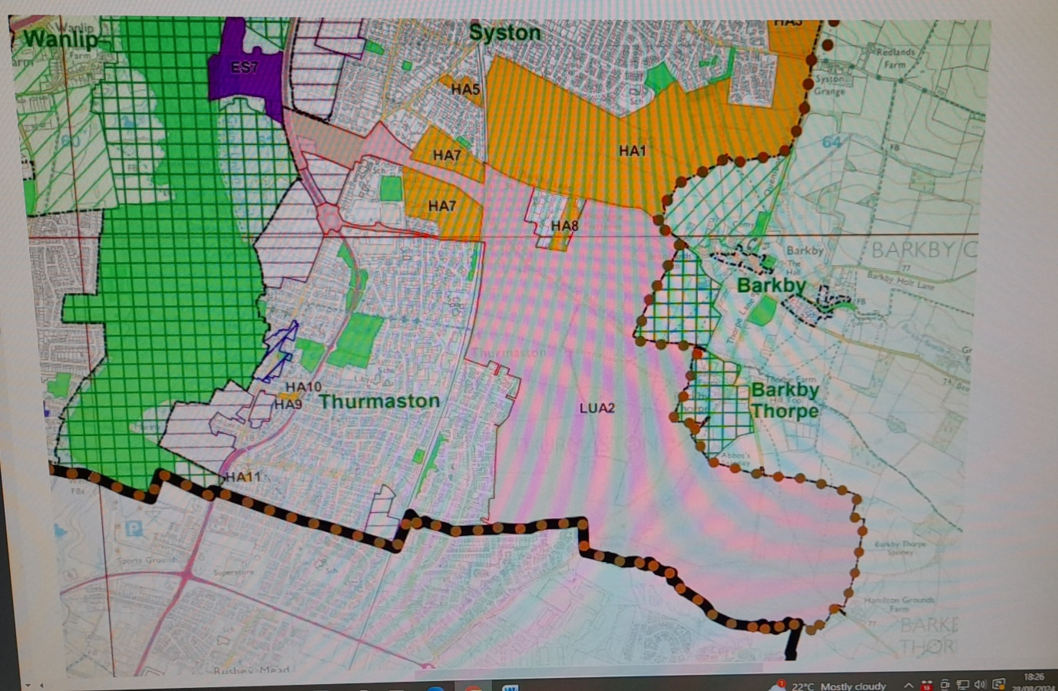  Area coloured pink  LUA2 is the 4500 houses of Thorpebury  Areas coloured orange  HA1 is the 960 houses south of Syston  HA3 (at very top of map) 195 houses Land north of Barkby Road  HA2 (north of HA3 and not shown on map) 200 houses off Barkby (Queniborough) Road  HA7 Land off Barkbythorpe Lane Thurmaston 180 houses  HA8 Former Woodgate Nurseries off Barkby Lane 46 houses  044/24 Declarations of Interest on the Agenda – Personal &  Prejudicial: None  045/24 To approve and sign the Minutes from the Parish Council Meeting and  the meeting minutes for the Annual parish council meeting held  on the 25th June 2024 in Barkby village hall:-  The minutes were signed by as a true record. No matters arising. The  meeting minutes will be posted on the parish council website. The clerk will also put a  draft copy of the meeting minutes of this meeting on the noticeboard.  Page 99  046/24Borough Councillor Report  Nothing to report  047/24County Councillor Report  None available  048/24Financial Reports:  Bank Reconciliation:  The balance on the 31st August 2024 was £31,076.65  Payments  Total authorized payments for the period 1st June 2024 – 31st August 2024 = £5,297.90  Receipts  Total income received for the period 1st June 2024 – 31st August 2024 = £3635.00  As of today the “Platinum group” balance of £2061.43, which sits in the Parish council  account.  049/24 Jelson’s update on Barkby Lane from meeting 3rd September 2024  On 3rd September, the PC met with Rob Thorley who is the Land Development Director  with Jelsons who are the housebuilders for HA8 on Barkby Road. We discussed our  usual concerns with regard to the detrimental effect this development would have on the  character of the approach to the village, the additional traffic this would create together  with a dangerous exit on to an already very busy road, the lack of amenities for example  schools, doctors and dentists and that, in any event, we are opposed to any further devel  opment in our locality. We also discussed the potential for reducing the number of houses  on the site to include only higher values homes which would be more in keeping with the  adjacent properties. We also discussed the environmental aspects of the site - bio diver  sity, the affect on wildlife and the annual issue of flooding. We also mentioned that we  concerned about aspects of the development of the site e.g. the evidence of asbestos and  how the grave in the site will be dealt with. Mr Thorley was very sympathetic to all of our  concerns and we will keep liaising with Jelsons to hopefully influence the final outcome to  the benefit of the local area.  051/24Clerk’s Report  - J1 Footpath (Brookside) – Clerk is still waiting to hear back from LCC who in turn have not heard back from Fisher German about what land ownership they have an interest in along the Brookside. The clerk will continue to chase as the concern on the state of the footpath along parts of the Brookside are a real concern to the village. The clerk will escalate the matter with Fisher German.  - Footbridge (J1b) along Brookside – The clerk continues to explore companies and gain quotes for steelworks and repair/remedial works.  - The national lottery grant – the footbridge grant is planned to be spent by the end of 2024. Page 100  - Street light – The clerk now has the solar light to replace the street light out along the Brookside. This will be sited in the next 2 weeks.  052/24 General Correspondence  - Declaration of office – Cllr Darren Heyes has signed as Vice Chair.  - Payroll – the clerk is trying to set up a payroll system with DCK payroll at present.  - HSBC – to assist with accessibility Cllr Chris Thompson and Cllr Dwayne Toon now have online access to the account.  - .gov.uk domain – the clerk has applied for this for the Parish Council, and has been successful in gaining funding to assist with this transition.  - “Barkby in bloom” – the members grant money awarded in December 2023 has been spent on weed killing and bulbs to plant around the village to enhance its beauty. The clerk will be asking for volunteers to plant around identified areas in and around the village.  - The steep steps leading up to the PROW across the field to Beeby Road are damaged. Clerk to report.  - Railings outside No. 36 Brookside have been damaged by the fallen willow tree.  053/24 Items for Next Months Agenda  Model financial regulations 2024  Footbridge  Footpath  Date of Next Meeting: Tuesday 12th November 2024 at 7.30pm at  Barkby Village Hall  The meeting closed at 8.30pm  Chairman:__________________ Date:___________________ | Clerk to do  Clerk to do  Clerk  Clerk  Clerk to do  Clerk to do

